z

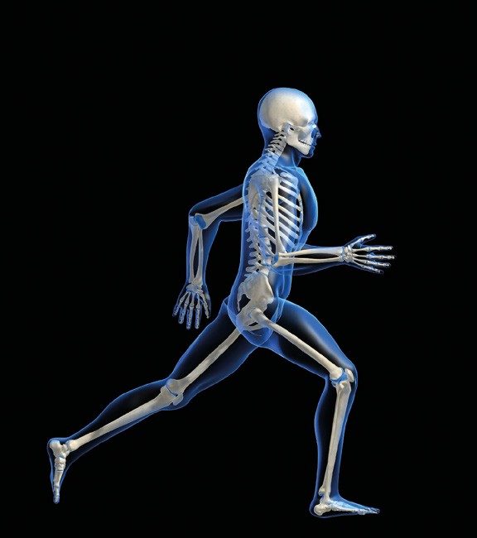

**Biomechanics**

**Introduction**

iStockphoto.com/Eraxion

**What is biomechanics?**

**Force and movement**

displacement velocity Acceleration

**Newton’s laws of motion**

the law of inertia

the law of acceleration

the law of action and reaction

**Momentum and impulse**

momentum impulse

**Resistive forces**

**Principles of motion** Angular motion and torque moment of inertia Projectile motion

**Balance and stability** centre of gravity base of support levers

# **Introduction**

In any given sport or physical activity the human body will undergo a series of trained, well-rehearsed movements to succeed in meeting the objective of that particular activity.

Whether the playing field is the pool or the pitch, the oval or the track, the athlete’s body responds to every plausible method of play. These movements are practised, timed, precise and, from the spectator’s perspective, seemingly natural and flawless. Yet their importance is immeasurable; completely undetectable by a scoreboard or time clock.

The possibilities and limitations of human movement are dependent on the environment in which we participate. To fully understand this relationship we turn to the study of biomechanics.

# **What is biomechanics?**

**Biomechanics** is the study of forces, both internal and external, and the effects of those forces on and within the human body. Whenever a force is applied to the body, biomechanics can analyse and interpret its cause and effect.

Through observation, measurement and analysis of training and competition performance, biomechanists use their expertise to support athlete development.

Biomechanics does not simply determine how our bodies *can* move; it is a science that allows us to work out how our bodies *should* move. Kicking a soccer ball, running a marathon or serving an ace are activities that, through biomechanics, can be performed more efficiently in order to produce optimum results.

To understand the usefulness of biomechanics, we need to examine the key areas of force, motion, balance and levers.

#### *Streamlining movement*

1. Athletes at the most elite levels spend years perfecting their technique so that they make the most efficient movements possible. Read ‘Anatomy of an athlete’ at the link provided, and explain what areas they have to focus on to optimise their movements.

*<flexibooks.com.au/w/22y>*

* 1. Kelsey
  2. Larissa
  3. Brooke

1. Why do track athletes have to limit the amount of time they spend practicing their specific sport, and focus much of their training on general strength and speed?

# **Force and movement**

**Forces** can most accurately be defined as either pushes or pulls that change an object’s movement. No object will demonstrate motion unless it is subjected to a force.

#### *Identifying forces*

1 State which type of force (push or pull) is responsible for the following examples of motion: putting the shot:

rowing a canoe:

kicking a football:

freestyle swimming:

Force can be produced either internally (through the contraction of muscles), or externally (through the effects of gravity, friction, water and air). It is typically described in terms of an object’s mass and its acceleration.

The unit of measurement for force is called a Newton (N), named after Sir Isaac Newton (1642–1727) a famous scientist who formulated the law of gravity and the laws of motion.

It is important to note that there are always **two** objects involved whenever a force is applied and that only an unbalanced force acting on an object can change its velocity.

For example, when a rugby player runs towards the tryline, an unbalanced force (his opponent) will attempt to prevent his progression through the play by tackling and throwing him off-balance. In this example, the unbalanced force decreases or slows down the velocity of the attacking player.

## **Displacement**

In order to describe the effects of movement, we must first know the initial position of an object and how that position changes to meet its objective. **Displacement** is the movement of an object in a specific direction.

Imagine that Venus Williams has just served the ball. Upon impact she may run forward from the baseline toward the middle service line to return her opponent’s volley. This movement from baseline to a new position on the court is known as displacement. At any point during her game, Williams’ displacement can be described by measuring in metres how far she is from her last position on the court. The total distance she runs over the course of her game can be measured by following the path created by her displacement.

## **Velocity**

The rate at which an object moves from one location to another is known as **velocity**. Velocity is characterised by speed and direction. To determine a person’s velocity, we must know that person’s displacement path and divide it by the time it has taken to complete it.



|  |  |  |
| --- | --- | --- |
| Velocity = | Displacement | or |
| Time |

For example, in a 100 metre sprint event, a sprinter who completes the race in 10 seconds has a velocity of 10 m/s.

When an object is travelling at a high velocity, the time it takes to cover a specified distance is less than an object travelling at a slower velocity. Simply stated, the winner of any race involving distance should always be the person with the **highest average velocity**. It is important to note that the calculation for velocity over an entire race provides an average result only.

As a sprinter pushes off the starting blocks, velocity rapidly increases for a time. By around the middle stages of the race, velocity should peak, the sprinter attempting to maintain this velocity to the end of the race. At any one point in the race an instantaneous velocity can be measured. This is often examined to determine precisely where in a race an athlete needs to further hone their skills in order to reduce time and improve average velocity.

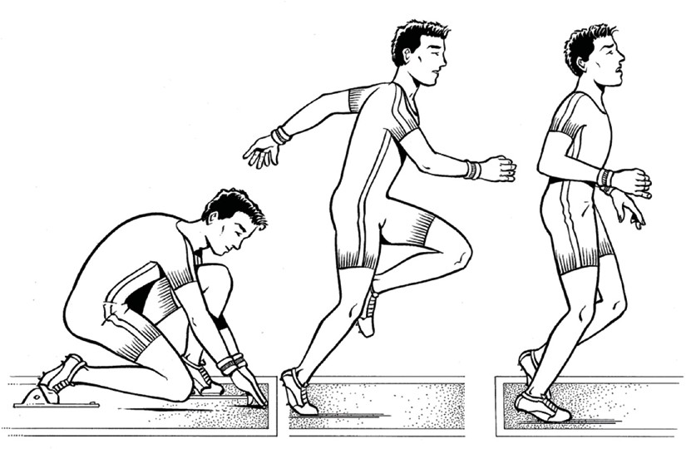

#### *And the winner is…*

1. In pairs, take turns to time how long it takes each of you to complete a 100 m sprint. a Work out your average velocity and share your results with the class.

7.1 m/s

* 1. Use the data to predict who is the fastest runner.

Probably kodi

* 1. Test your hypothesis by holding a 100m final to determine who is the fastest runner.

no

1. What other aspects may influence a runner’s final result?

The wind?, the surface they are running on

## **Acceleration**

In the velocity example, the sprinter uses an internal force to create motion. When we apply force to something to make it move, our objective is to speed it up, slow it down, stop it completely or make it change direction. This change in velocity over a specific period of time is called **acceleration** (or deceleration, if the force slows the object down).

|  |  |
| --- | --- |
| acceleration = | final velocity − initial velocity |
| time |

To calculate the acceleration of the sprinter in the previous example, we would take the initial velocity (0 m/s) from the final velocity (10 m/s) and divide by the 10-second time period it took to complete the race. This gives an acceleration (or a change in velocity) of 1 m/s2.

Compare this to a skater who goes from a standstill position to a speed of 6.7 m/s in 12 seconds. The acceleration of the skater is calculated here:

*a* = *vf* - *vi t*

Since the skater was at a standstill position and not in motion, the initial velocity of the skater was zero. The skater reached a speed of 6.7 m/s in 12 seconds, which is the final velocity.

|  |  |  |  |
| --- | --- | --- | --- |
| *a* = | 6.7 m/s - 0 m/s | = | 6.7 m/s |
| t | 12 |

*a* = 0.56 m/s 2

#### *Understanding acceleration*

1. Compare the rates of acceleration for the sprinter and the skater. Can you think of reasons why the sprinter’s acceleration is greater?

When acceleration is greater, it tells us that velocity is changing quickly; when it is smaller it tells us that velocity is changing slowly. **Zero acceleration** means that there may be no change in velocity. As with a tennis ball or golf ball flying through the air, it is possible to be travelling very quickly at zero acceleration.

Furthermore, acceleration cannot be sustained for the duration of an event. It is obviously important at the start of events but once maximum velocity has been achieved, there is no change in velocity (zero acceleration) until the end of the event when velocity changes as a result of deceleration.

1. Explain why rapid acceleration is much more important for a sprinter than it is for a middle-distance or long-distance runner.
2. Predict what you believe would be faster: running 100 metres from a standing start or a crouch start.

Test your hypothesis with a partner and explain your results.

Like velocity, the calculation for acceleration produces an average result only. As it is possible for acceleration to vary at given intervals during a specified time, it is also possible to examine instantaneous acceleration at differing points in time.

# **Newton’s laws of motion**

Three scientific laws of motion developed by Sir Isaac Newton in 1687 govern the reaction of objects to applied forces.

## **The law of inertia**

An object at rest will remain at rest until a force causes it to accelerate. An object in motion will continue its movement in a straight line unless a force causes an acceleration to make it slow down or change direction.

## **The law of acceleration**

When a force acts on an object, the acceleration that takes place depends on the amount of force applied, and the mass of that object.

This law is expressed in an important equation frequently used in the study of human movement and sport.

*Force (N)* = *mass* x *acceleration* or *F* = *ma*

This equation can also be expressed as follows.

*F*

|  |
| --- |
| *Force (N)* |
| *mass* |

= *acceleration* or = *a m*

Keeping in mind that objects will move in the direction of their force, an object with a larger mass is harder to accelerate than an object with a smaller mass. Compare bowling a ten-pin bowl with a mass of 7 kg to throwing a basketball with a mass of 0.5 kg. Applying a force of 10 N and using the law of acceleration, we can conclude the following:

bowling ball *F* = *ma* basketball *F* = *ma*

*a* = *a* =

|  |
| --- |
| *F* |
| *m* |

|  |
| --- |
| *F* |
| *m* |

*a* = *a* =

|  |
| --- |
| 10 N |
| 7 kg |

|  |
| --- |
| 10 N |
| .5 kg |

*a* = 1.43 m/s2 *a* = 20 m/s2

The basketball accelerates at a much greater rate than the bowling ball because its mass is smaller. The bowling ball requires a force larger than 10 N if we want to increase its acceleration and change its speed. Conversely, smaller masses are easier to accelerate and do not require as great a force to change speed. In basic terms, acceleration increases by the same or proportional amount that mass decreases and vice versa.

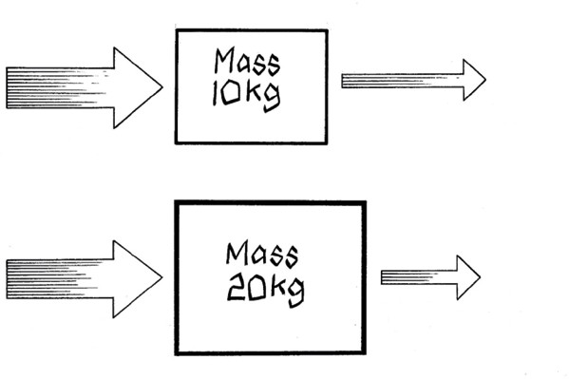

F=200 N

Acceleration

=20 m/s2

F=200 N

Acceleration

=10 m/s2

#### *Calculating acceleration*

1. Calculate the following:

|  |  |  |
| --- | --- | --- |
| **Force (N)** | **Mass (kg)** | **Acceleration (m/s2)** |
| 100 | 50 | 2 |
| 150 | 50 | 3 |
| 200 | 50 | 4 |

1. The relationship between the law of inertia and the law of acceleration depends on one underlying difference. What is it?

## **The law of action and reaction**

For every action, there is an equal and opposite reaction. This means that when an object exerts a force on a second object, the second object must also exert an equal-sized force back onto the first object in the opposite direction.

#### *Applying Newton’s laws of motion*

1 In the illustration provided, mark beside the arrows which force is the **Action** and which is the

**Reaction** of the sporting example used.

Briefly explain how the law is at work for each.

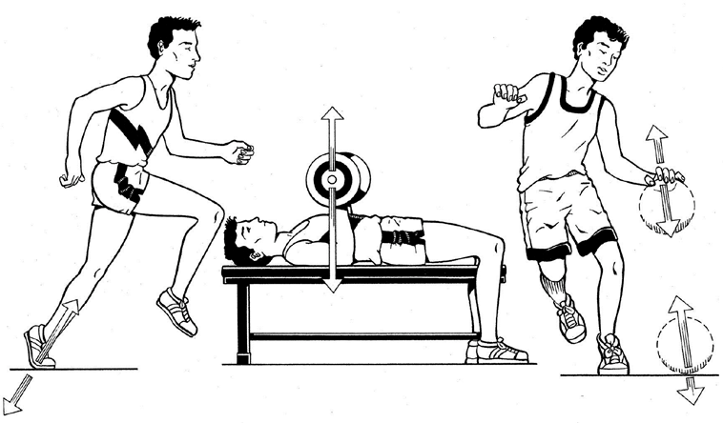

The action in each example is equal and opposite. The runner exertes force on the ground, the weight lifter exertes force on the barbell and the basketball exertes force on the ball

1. Use the third law of motion to describe what happens when teams in a scrum push against each other but neither moves.
2. Why is running on sand more difficult than running on a track?
3. Explain how all three laws of motion operate when a canoe is rowed along a river.

# **Momentum and impulse**

Two concepts associated with Newton’s laws of motion are momentum and impulse.

## **Momentum**

Newton’s first law of inertia tells us that once an object starts to move, its tendency is to keep moving. This ‘quantity of motion’ is called **momentum**. It is measured by multiplying the object’s mass by the rate at which it is moving (velocity).

If a shot-put has a mass of 7 kg and a velocity of 10 m/s, the formula for momentum (mass x velocity) tells us that the momentum of the ball is 70 kg m/s. Compare this to a discus with a mass of 2 kg and a velocity of 20 m/s. Its momentum only achieves 40 kg m/s.

The shot-put has the greater momentum because, although it is not travelling as fast as the discus, its mass sufficiently contributes to greater momentum.

*The more mass an object has, the greater its momentum.*

However, what if the discus also weighed 7 kg? It would have a greater momentum than the shot-put because its velocity is greater.

*The faster an object moves, the greater its momentum.*

### Conservation of momentum

How difficult is it to stop an object that has gained momentum? It depends on the total momentum of both objects both before and after their point of impact.

Successfully catching a football will depend both on the ball’s momentum and the momentum of the hands as both absorb the impact of the collision. This principle, known as **conservation of momentum**, is best explained by Newton’s third law that for every action there is an equal and opposite reaction, and it is particularly relevant to contact sports.

AFL players who have a large mass and can run fast can achieve high momentum, and are therefore very difficult to stop. A player with less mass must run more quickly in order to generate the same amount of momentum, otherwise they become easier to stop when tackled.

When a collision between two objects occurs, the total momentum of the two objects before impact is equal to the total momentum after impact.

#### *Understanding momentum*

* 1. If a 156 g cricket ball and a 151 g baseball are moving at the same velocity, which will be harder to catch? Explain why.

The cricket ball because it is heavier and has more enertia

* 1. If two rugby players both with a mass of 100 kg are moving towards each other at different velocities, who will be easier to stop? Explain why.

The Slower one because he has less enertia

* 1. As a class, you will be given the opportunity to participate in a tug-o-war. Use the conservation of momentum principle to explain what was happening throughout the competition.

2 teams attempt to pull harder than the other

* 1. True or false? A lighter player can never seriously affect a heavier player in a contact. Explain your reason.

False, if the ligher player has a knife, that would affect the heavier player seirous in contact

* 1. In groups of three, take turns doing a chest pass using a netball or a basketball. Try different catching methods to determine which is the best at absorbing the impact during catching. Share your answer with your class and explain your decision.

n/a

## **Impulse**

Applying a force to an object over a given amount of time causes a change in momentum. This change is called **impulse**.

##### Impulse = Force (N) x Time of force application(s)

The formula for impulse tells us that a change in momentum is affected by two factors: the strength of the force applied and the time over which a force is applied.

In freestyle swimming, the arms apply force over a great range of motion increasing the time over which forces can be applied.

Conversely, in the case of a field hockey player driving the ball the collision is over in an instant. Therefore, in this case impulse has more to do with force than the time over which force is applied.

Impulse and momentum are strongly related. The more impulse applied to an object, the greater its velocity since its mass remains constant.

#### *Evaluating impulse and momentum*

1. Explain how impulse and momentum are present in kicking a soccer ball.

n/a

1. Perform a number of cricket deliveries to experiment the ways in which a cricket player changes the momentum of a ball during bowling.

n/a

# **Resistive forces**

If a force is being applied to an object to make it move, a **resistive force** acts in opposition to it in order to resist or slow its movement.

**Gravity** is a constant force acting vertically to the centre of the earth. It acts through the centre of mass of the body opposing upward movement away from the earth.

**Fluid resistance** is a force arising from air or water. Moving through the fluid requires an object to push it aside, creating a **drag** force that tends to slow movement. It is most prevalent in high-velocity sports such as sprinting and cycling. In a basic example, if running velocity increased by a factor of two then drag resistance would increase by a factor of four. As a result clothing and equipment are specially designed to minimise its effect.

**Friction** is a force that opposes movement due to contact between two surfaces moving across each other. Depending on the sport, increased friction can improve a player’s performance. Footwear is designed to increase friction between the ground and a player’s feet so that slipping is minimal and stability can be maintained.

In other sports, such as those played on snow or ice, decreasing friction by waxing skis and sharpening ice skates maintains the slipperiness of their surfaces.

#### *Identifying forces*

1 List five sports, or skills within sports, and explain how any or all of the resistive forces mentioned affect performance and how they may be counter-balanced.

Ice hockey has little friction meaning the puck slides further

2 In teams of four, participate in a handball competition in various venues across the school, including a grass court, a bitumen court and a cement/wooden court.

1. Predict what factors will affect your performance and which court service you believe will be more suitable for optimal performance. Justify your response.
2. Revisit your opinion at the conclusion of the competition to determine whether or not you were correct.

# **Principles of motion**

So far we have been looking at how forces cause, alter, sustain or terminate movement. Most of our examples have been about the occurrence of motion in a straight line. However, in sport, movement does not only occur in a straight line (linear motion), but can also occur as a rotation around a fixed point (angular motion), or a combination of both (general motion).

**Motion** can be defined as a change in the location of an object in space and time. Even the most basic of human movements—bending the leg, turning the head, twisting the torso—demonstrate a change in location. Each change is the result of an applied force.

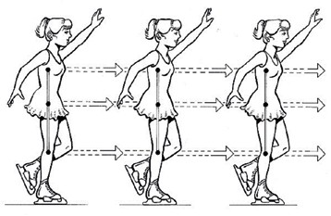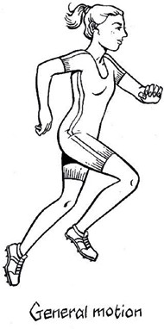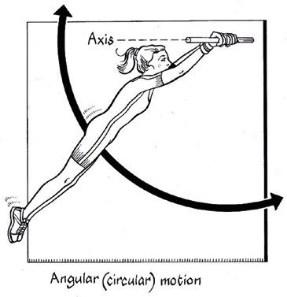

*Linear motion (skater), general motion (runner) and angular motion (gymnast)*

## **Angular motion and torque**

**Angular motion** is achieved when the line of the force is directed to one side of the axis of rotation. This is known as

**torque,** a turning effect that changes the rotational acceleration of the object.

In sport, objects (including the human body) will spin, bend or rotate in some way. The degree to which these movements are accelerated depends on the amount of torque applied and the distance from the axis of rotation to the line of force. Greater torque means greater change in the rotational acceleration of the object, especially if there is greater distance between the axis and the line of force.

#### *Identifying motion types*

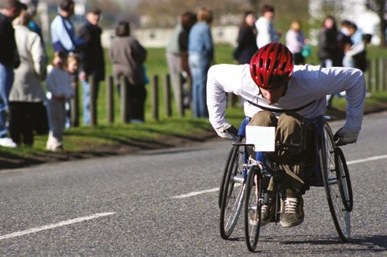1 State whether the following activities constitute linear, angular or general motion:

iStockphoto.com/ianmarchant

1. sprinter in a 100 m sprint
2. swimmer in a 100 m butterfly event
3. sliding down a water slide
4. gymnast on the horizontal bar

## **Moment of inertia**

*Hand force applied to the push rim at a given distance from the axle of the wheel delivers torque to the wheel, which in turn translates to increased velocity of the wheelchair.*

The resistance to change of an object in angular motion is known as its **moment of inertia**. The greater an object’s mass and its distance from the axis of rotation, the more difficult it will be to change the rotation of the object and vice versa.

In junior sport, the moment of inertia can be greatly reduced by modifying equipment. Lightweight bats and short-handled racquets reduce mass and the distance from axis of rotation of the hands to the centre of mass of the bat, making it easier for younger or inexperienced participants to change the rotation of the bat.

#### *Modifying inertia*

1 Choose three sports and list the modifications that are allowed for younger players to encourage greater success.

### Angular momentum

**Angular momentum** measures the amount of a rotating object’s angular motion. A rotating object will be harder to stop if its moment of inertia and rotational velocity are high, and easier to stop if its moment of inertia and rotational velocity are low.

Conservation of angular momentum is a term used to describe how the total momentum of a body stays constant during a movement. Athletes can change their body shape to assist with this. For example, a diver can move from a straight position into a tuck position in order to decrease inertia through minimising the distance from the axis of rotation. This motion increases velocity, conserves angular momentum and makes it very difficult for an unbalanced torque to destabilise the movement.

#### *Understanding the rate of rotation*

1 In the somersault, various body positions such as the tuck and pike will influence the rate of rotation (angular velocity). Explain how this is true.

## **Projectile motion**

The movement of an object through the air is referred to as **projectile motion**. The objective of many sports is to control and manipulate the flight path of a projectile in order to achieve optimal distance for that particular sport.

The velocity, height, angle and attitude at which an object is released together with air resistance affects its flight path or

**trajectory**. The object’s orientation to its trajectory at release is its **attitude**.

### Velocity at release

When a shot-putter releases the shot-put with increased velocity, all else being equal the shot will increase its time in the air and travel over a greater distance. Of all factors at release, velocity accounts for the greatest increases in distance.

### Angle of projection

The shape of the trajectory depends on the angle at which the object is released and will vary across many sports. In the absence of air resistance an object would travel in a true parabolic trajectory. In reality, and in the presence of air resistance, a typical sport object delivered from shoulder height would be projected at approximately 45° to cover the greatest possible distance.

### Height of release

As a general rule, increasing the height of the projection results in greater time in the air and distance travelled if velocity and angle of projection are held constant.

### Air resistance and spin

Air resistance, wind and other elements may alter the projectile’s trajectory. This is why in many sports such as tennis or soccer, to ensure equal advantage, teams are required to change sides of the court or pitch.

The greater the surface area of the projectile and the more velocity it has, the greater the effect of air resistance.

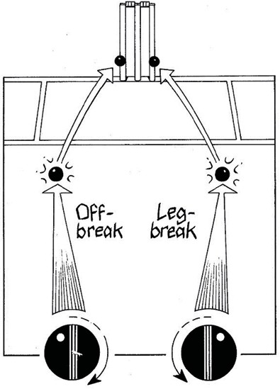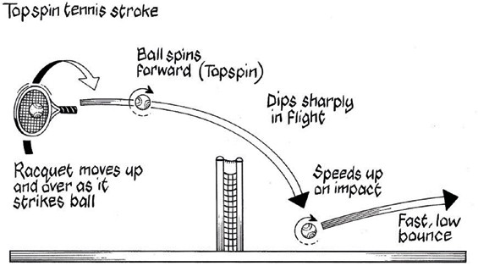With a spinning ball, differences in the velocity of airflow around the surface of the ball will result in a condition known as the **Magnus effect.** The differences in airflow, in turn, result in changes to the pressure on either side of the ball causing it to deviate from its flight path. Tennis players, soccer players and golfers are examples of athletes who use the Magnus effect to curve the ball’s trajectory, either giving the ball topspin, backspin, slice or draw.

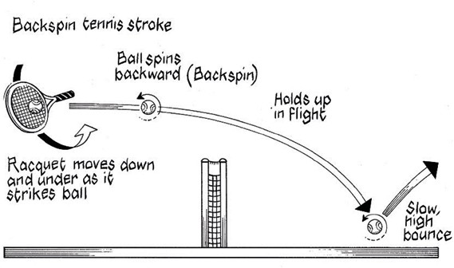*The direction of spin, in a tennis stroke and in the off break and leg break bowl for a right-handed cricket batsman*

#### *Understanding spin*

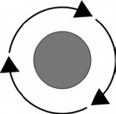1 This diagram shows a side-on view of a table tennis ball spinning in flight.

Direction ball is travelling

1. What type of spin is on the ball?
2. When compared to a ball without spin, what effect does this type of spin have on the flight of the ball through the air?
3. Explain how the player would be able to impart this type of spin on the ball.

# **Balance and stability**

**Balance** is the ability to maintain equilibrium and in biomechanics it plays an ever-present role in human movement.

For balance to exist, coordination and control are essential components. These are strongly highlighted in sports such as figure-skating and gymnastics where rules indicate that set positions (known as **static balance**) must be maintained. Other sports such as tennis or basketball require balance while moving, such that a body’s position can be altered easily (known as **dynamic balance**).

While balance may not be the overall aim of a sport, a person’s level of **stability**, that is the ability to resist movement or disruption to balance, can have far greater implications for their success. There are several factors that influence balance and stability.

## **Centre of gravity**

**Centre of gravity** is the centre of balance of an object and the centre of the gravity effect on the body. Objects with regular shapes and mass distribution, such as a ball or ruler, have their centre of gravity in their geometric centre.

With arms at their sides, humans have their centre of gravity located approximately mid-height (57 per cent of the way up the body or slightly lower for females). However, a person’s centre of gravity changes with their body position and, depending on the movement, can often be located outside the body.

Lowering one’s centre of gravity can maintain stability. Movements in any number of sports, from the tackle in Australian football to wrestling, require the participants to bend their knees slightly as a method of resisting being toppled over by an opposing force.

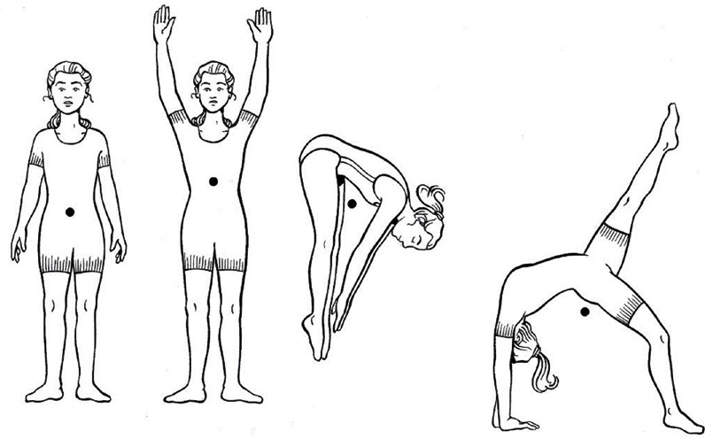

## **Base of support**

**Base of support** refers to the part(s) of the body in contact with a surface. The larger the base of support in the direction of the oncoming force the greater the body’s stability. A rugby player who increases his base of support by widening his stance towards the oncoming player and lowering his centre of gravity by bending his knees will be harder to tackle and turn over.

#### *Identifying base of support*

1 Perform the following gymnastic skills: handstand, front support, V-sit, shoulder stand, stork stand. a Identify the base of support for each position.

b Rank each skill in order of most to least stable.

### Line of gravity

In the figures of the standing girls, the centre of gravity is directly in line with the middle of the base of support. Drawing an imaginary line between these points is called the **line of gravity**. When the line of gravity moves outside the parameters of the base of support, stability is lost.

#### *Applying principles of gravity*

1. Find the centre of gravity of a ruler. Using an eraser, explain how distribution of mass affects centre of gravity.
2. 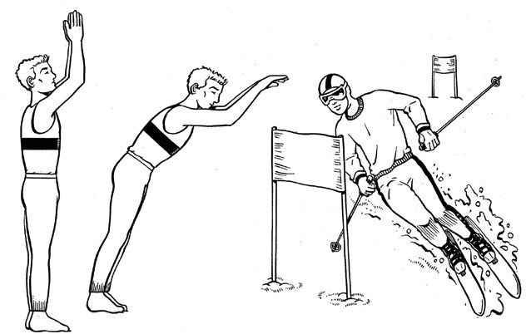Use a ruler to help mark the centre of gravity, the line of gravity and the base of support on these diagrams.
3. Explain the importance of balance while performing a skill such as hitting a baseball.

## **Levers**

To understand how the human body applies force we turn to **levers**, machines that help us transfer energy from one object to another.

In the human body, bones, muscles and joints work together to make up lever systems. The bone is a rigid bar that revolves around a fulcrum or axis (the joint) whenever a force is applied to overcome a resistance. Attached to the bone are muscles, which deliver the force, and are required to move the resistance. In biomechanics, there are three types of levers within the human body.

*First class lever*—the fulcrum or axis is located between the load (resistance) and the effort (force) needed to move it.

*Second class lever*—the load is located between the axis and the effort.

*Third class lever*—the effort is located between the axis and the load.

Most sporting situations require the use of third class levers, with first and second class levers having limited applications.

Third class levers have the effort (muscle) located between the axis (joint) and the load (resistance). This system provides a long resistance arm (RA) and the lever can be swung through a much greater range of motion and with a much greater velocity. Levers in the human body are therefore more adept at increasing our ability to move quickly than increasing our ability to move heavy objects.

**Extended levers**, or sporting equipment such as bats, sticks and racquets, help illustrate this point. A baseball bat has a long resistance arm extending from the hands to the end of the bat and, while it requires more effort to swing it, increasing the RA means that the end of the bat has a greater range of motion. The bat strikes the ball with a much greater force than it would have had the implement not been used, and as a result generates a higher ball velocity.

The effectiveness of such an extended lever to maximise performance will therefore depend on its length, the ease with which it can be swung and the muscular strength of the player.

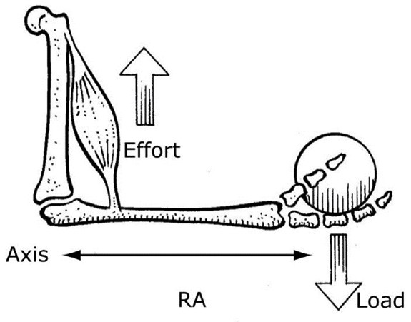

*A typical third class leverage system*

#### *Understanding levers*

1. Why is it often a disadvantage for a younger or inexperienced player to use a longer racquet, bat or club?
2. Explain why most levers in the body have short force arms and long resistance arms.